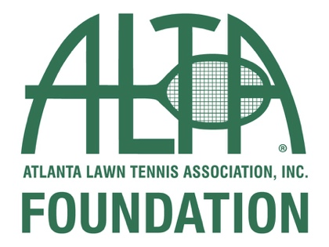

Each year, the ALTA Foundation works tirelessly to celebrate some of the most talented and outstanding students within the ALTA family.

Please join us as we extend our heartfelt congratulations to our deserving winners!

Isabelle Coursey- Atlanta, GA
ALTA Facility: Dekalb Tennis Center
Graduate of: Chamblee High School
Attending: Georgia Tech

Riley Hamrick- Peachtree Corners, GA
ALTA Facility: Peachtree Station Swim and Tennis
Graduate of: Norcross High School
Attending: University of Georgia

Athena Misewicz- Dunwoody, GA
ALTA Facility: Dunwoody Country Club
Graduate of: Dunwoody High School
Attending: University of Georgia

Prisha Mody- Johns Creek, GA
ALTA Facility: Peachtree Station
Graduate of: Johns Creek High School
Attending: University of Georgia

Mara Opre- Suwanee, GA
ALTA Facility: Sharon Springs Park
Graduate of: Lambert High School
Attending: Anderson University

Ben Stone- Suwanee, GA
ALTA Facility: Mayfair/ St. Clair
Graduate of: Lambert High School
Attending: University of Alabama

Ally Turnbough- Snellville, GA
ALTA Facility: Briscoe Park
Graduate of: Greater Atlanta Christian School
Attending: Clark Atlanta University

Davis Wall- Duluth, GA
ALTA Facility: Canterbury Woods
Graduate of: Peachtree Ridge High School
Attending: University of Georgia

